Sunset Cove Development Homeowners Association
Annual Meeting of Association Members
Zoom Meeting, Tuesday, January 23rd 2024, 7pm PST

Agenda

Call To Order Doug Berard

Welcome
Zoom etiquette
Introduction of 2024 Directors & Officers
Announce number of returned ballots
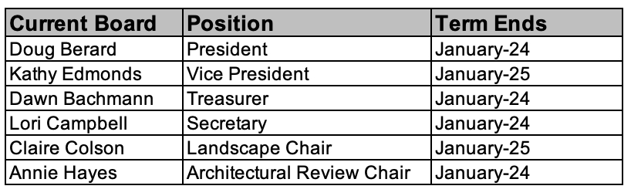
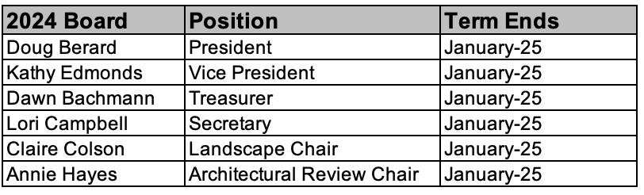

Formation of Nomination(s) Committee
Committee Members-Paul Allen, Amy Schnabel, Kim Graf, Doug Berard

Recognition of Officers serving longer terms-Annie Hayes, Lori Campbell, Dawn Bachmann

2023 Financial Report and 2024 Budget Dawn Bachmann
Explanation of 2024 Budget
Announce Approval by Membership
Dues increase $300 to $400
2024 assessment due date 2-15-2024

Committee Reports
Architectural Review Committee Annie Hayes
Audit Committee Kathy Edmonds
Landscape Committee Claire Colson
Publicity Committee Doug Berard

NEW BUSINESS: Doug Berard
2024 Projects
2024 Board Meeting Dates-Zoom Platform
Notes: Dates may move due to Board Member availability throughout the year. All dates and times will be posted on the SCHOA website 1 month in advance of the scheduled meeting. Schedule is updated annually.

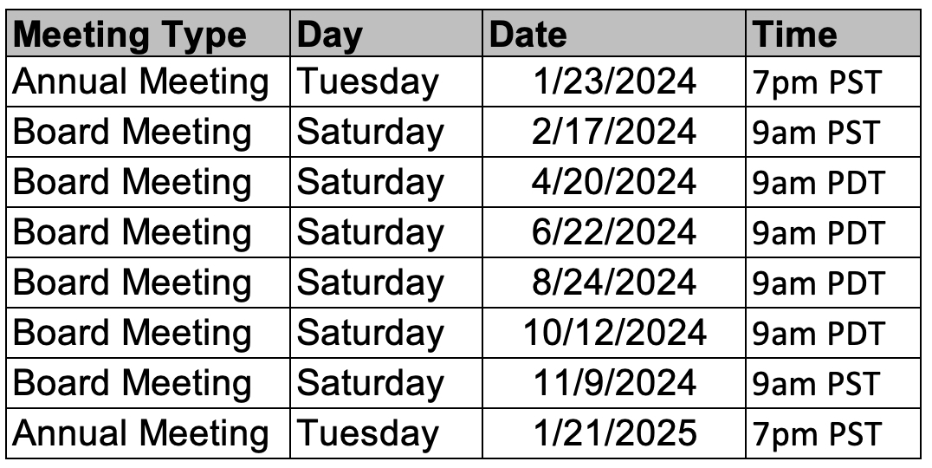

Announcement of Next Board Meeting-February 17th, 2024 9am pst Doug Berard
Adjourn Meeting Doug Berard

